**Distribute Your App Across a Swarm Cluster**

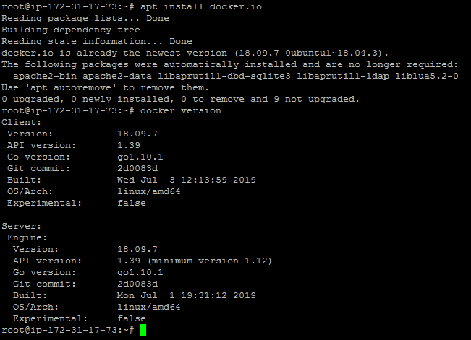

Setting up Docker swarm with multiple nodes

* Edit the **/etc/hosts** file across the two nodes via **gedit** or **vim** and make the following changes:

172.31.17.73dockermanager

172.31.86.69dockerworker1

* After modifying the host file with the details mentioned above, check the connectivity with **ping** between all the nodes
* From Docker Manager Host instance:

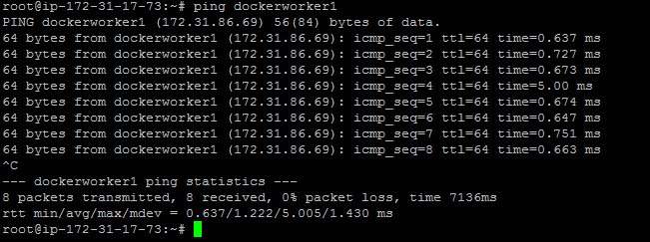

* From Docker Worker Node instance:

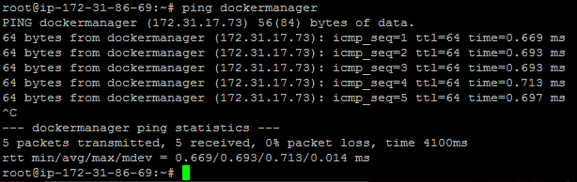

* Initialize the Docker swarm mode by running the following docker command on the **dockermanager** node

docker swarm init --advertise-addr<manager node IP address>

docker swarm init --advertise-addr172.31.17.73

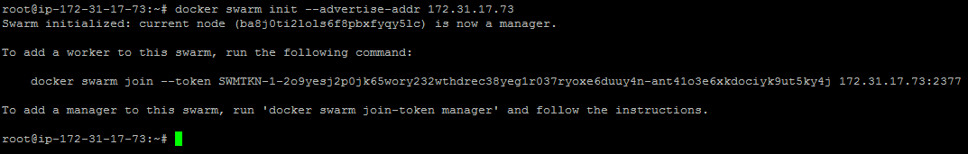

* Once the swarm cluster is initialized, allow the ports mentioned below in security groups





* While initializing the Docker swarm cluster, you will get docker swarm join command which can be executed on node manager to add node to swarm cluster
* Run the command below to see the node status

docker node ls



Deploying a custom Docker image to a Docker swarm cluster

* Create service in Docker swarm cluster

docker service create --name webapp --publish 8080:8080 --replicas 2 jocatalin/kubernetes-bootcamp:v1

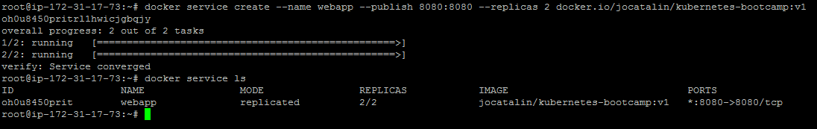

* You can now validate if Docker containers got deployed on both nodes or not using the command below

docker service pswebapp

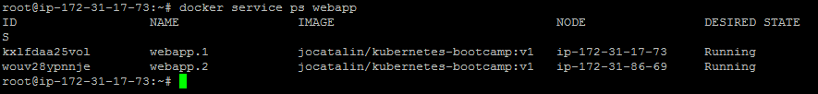

**Please Note:** We can validate the application using the **curl** command to see if the application is up and running.

